
Lesson 5 Teacher's Key
Godot Engine
INSTRUCTOR ONLY - do not distribute to students

Level 1 - Complete Worked Solution
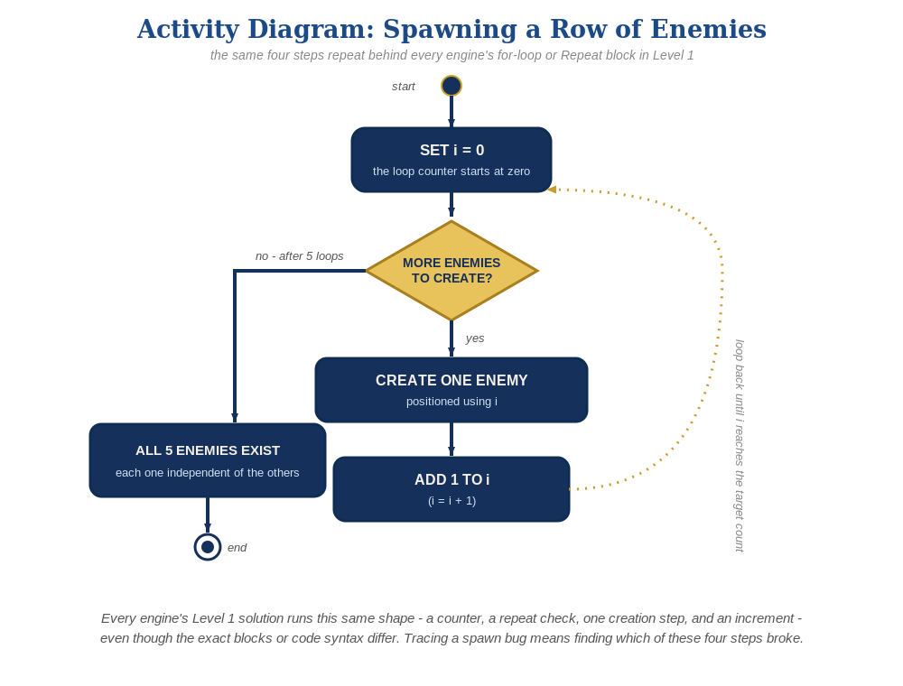
The spawn loop, in general - the same counter, repeat check, creation step, and increment behind Level 1 in every engine, whatever the exact blocks or syntax look like.
A for loop in the main scene's own script - enemy.tscn itself needs zero changes from Lesson 4:
# Main scene's script:
var enemy_scene := preload("res://enemy.tscn")
func _ready():
for enemy_count in range(5):
var new_enemy := enemy_scene.instantiate()
new_enemy.position = Vector2(150 + enemy_count * 200, 50)
add_child(new_enemy)

Level 2 - Complete Worked Solution
enemy.tscn's own script (its Hitbox's area_entered connection and hit-response) is fully self-contained, so every instance the loop creates behaves independently and correctly with no extra code needed for Level 2.

Level 3 - All Worked Solutions
Every stretch-goal idea from the handout, fully worked - not just one. Useful for validating each idea actually works before class, and as a ready reference no matter which one a student ends up picking.

Sound: already works
Every spawned enemy carries its own Hit AudioStreamPlayer2D from Lesson 4 - no changes needed.

Visual: striped row
Set modulate based on the loop index right after instancing, from the spawner's own script. Color(0.8, 0.1, 0.2) is a deep crimson red (mostly red, small amounts of green/blue) and Color(0.95, 0.4, 0.5) is a lighter dusty rose/pink (same red-dominant mix, just brighter with more green/blue mixed in) - alternating them produces a row where every other enemy is a visibly different shade of red, not a blended new color:
for enemy_count in range(5):
var new_enemy := enemy_scene.instantiate()
new_enemy.position = Vector2(150 + enemy_count * 200, 50)
if enemy_count % 2 == 0:
new_enemy.modulate = Color(0.8, 0.1, 0.2)
else:
new_enemy.modulate = Color(0.95, 0.4, 0.5)
add_child(new_enemy)

Structure: spawner vs. behavior stay separate
The main scene's _ready() only ever creates and positions enemies - it never reaches into an enemy's hit-response logic, which stays entirely inside enemy.tscn's own script.

Complete Level 3 solution (all 3 goals combined)
The spawner loop with the visual idea added - sound needs no changes since it already lives on each enemy instance:
var enemy_scene := preload("res://enemy.tscn")
func _ready():
for enemy_count in range(5):
var new_enemy := enemy_scene.instantiate()
new_enemy.position = Vector2(150 + enemy_count * 200, 50)
if enemy_count % 2 == 0:
new_enemy.modulate = Color(0.8, 0.1, 0.2)
else:
new_enemy.modulate = Color(0.95, 0.4, 0.5)
add_child(new_enemy)

